Life Insurance Claims Guidance
  - Tokyo Marine Thailand - A Complete Guide for Individual Customers

About Tokyo Marine Thailand Life Insurance

Tokyo Marine Life Insurance (Thailand) Public Company Limited brings over 140 years of global insurance expertise to Thailand, delivering comprehensive life protection with integrity and customer-centric service [1]. As part of the Tokio Marine Group, we are committed to supporting our policyholders and their families through every stage of life, including the claims process. This guide provides individual customers with clear, step-by-step information to help you navigate Life Insurance claims smoothly and confidently. Our claims process is designed to be transparent, efficient, and supportive during what can be a difficult time for you and your loved ones.

Understanding Your Policy and Coverage
Before filing a claim, it is essential to understand your Life Insurance policy and its coverage provisions. Your policy document outlines the specific benefits, coverage limits, exclusions, and conditions that apply to your insurance contract.

Key Policy Elements to Review
• Types of Coverage: Death benefits, critical illness riders, total permanent disability coverage, or medical expense reimbursement
• Coverage Limits: Maximum benefit amounts and any applicable sub-limits for specific conditions or situations
• Beneficiary Designations: Proceeds are paid according to the beneficiary designation form on file, regardless of what a will may state
• Premium Payment Status: Ensure premiums are current to maintain active coverage

Common Policy Exclusions
Policy exclusions typically include:
• Death resulting from suicide within the first policy year
• Certain pre-existing conditions not disclosed during application
• Death resulting from illegal activities or criminal acts
• War or acts of terrorism (depending on policy terms)
• Aviation-related deaths for non-commercial passengers (in some policies)

Keeping Your Policy Information Current
Maintaining up-to-date policy information helps ensure your family can initiate claims promptly when needed:
• Store your policy number and insurer contact details in a secure, accessible location
• Inform trusted family members where policy documents are kept
• Review and update beneficiary designations after major life events (marriage, divorce, birth of children)
• Keep copies of all policy amendments and riders
• Maintain records of premium payments and policy correspondence
Understanding these fundamental aspects of your policy ensures you and your beneficiaries are prepared when the time comes to file a claim.

When to File a Claim: Common Scenarios
Life Insurance claims can be filed in various situations depending on your policy coverage. Understanding when you are eligible to file a claim ensures you receive the benefits you are entitled to under your policy terms. The most common claim scenarios include death of the insured, where beneficiaries file for death benefit proceeds; critical illness diagnosis, where the insured files for lump-sum benefits upon diagnosis of covered conditions such as cancer, heart attack, or stroke; total permanent disability, where the insured claims benefits if unable to work due to disability meeting policy definitions; hospitalization and medical expenses, where the insured seeks reimbursement for eligible medical treatment costs; and accidental death or dismemberment, where additional benefits are payable if death or injury results from a covered accident. Each scenario has specific documentation requirements and eligibility criteria outlined in your policy contract.
Claim Scenario | When to File | Key Benefit
Death of Insured | File as soon as death certificate is available | Pays death benefit to beneficiaries
Critical Illness | File upon diagnosis of covered illness | Pays lump-sum benefit to insured
Total Permanent Disability | File after disability determination | Pays disability benefit or waives premiums
Hospitalization | File after treatment with receipts | Reimburses eligible medical expenses
Accidental Death/Dismemberment | File after accident with police and medical reports | Pays additional accidental benefit

Step-by-Step Claims Process
Tokyo Marine Thailand has streamlined the claims process to ensure efficiency and clarity for our customers. The process consists of five main steps that guide you from initial notification to payment receipt. Step 1: Notify the insurer as soon as possible after the incident or death occurs, as most policies require notification within 24-72 hours [2]. You can notify Tokyo Marine through multiple channels including calling the customer service hotline at 1159, visiting the Head Office or any branch office, or contacting your servicing agent. Step 2: Obtain and complete claim forms, which are available at any Tokyo Marine office, downloadable from the website, or can be requested by mail or fax to 02 619 4083 . Step 3: Gather all required supporting documents as outlined in the next section, ensuring completeness to avoid processing delays. Step 4: Submit your completed claim forms and supporting documents to the Individual Claims Department at 1 Empire Tower, 26th Floor, South Sathorn Road, Bangkok 10120, or hand them in at any branch office . Step 5: Track your claim status and await the review process, which typically takes 3 business days for complete submissions, with payment processed within 15 days of approval [1].
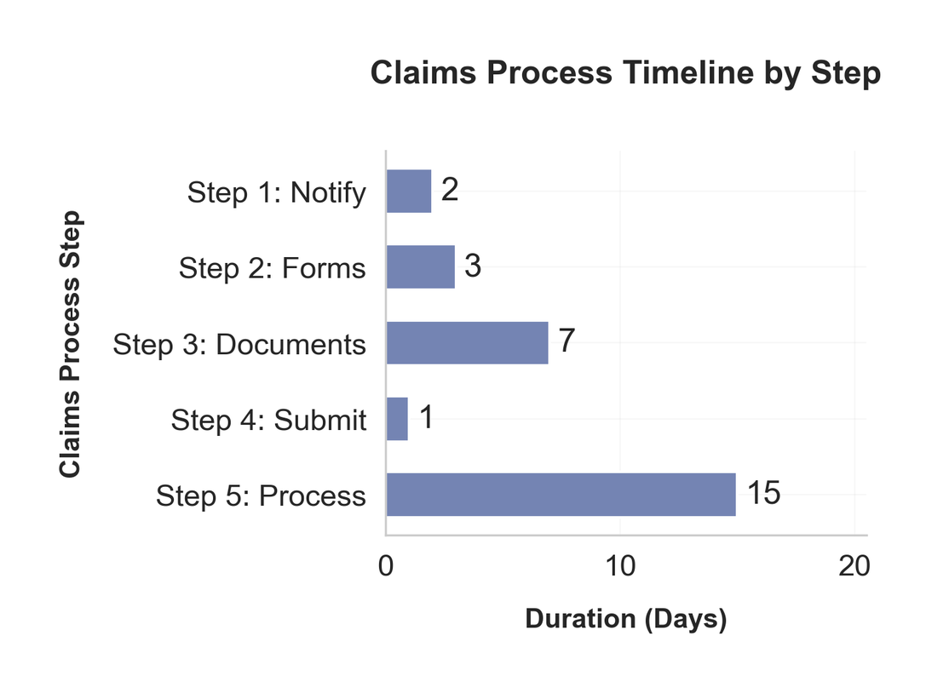
The timeline chart above illustrates the typical duration for each step in the claims process. Step 1 Notification typically takes 0-2 days, Step 2 Obtain Forms takes 1-3 days, Step 3 Gather Documents requires 3-7 days, Step 4 Submit Claim takes 1 day, and Step 5 Processing and Payment takes 3-15 days [1]. The entire process from initial notification to payment receipt can be completed in as little as 8-28 days, depending on the completeness of your documentation and the complexity of your claim.

Required Documentation and Forms
Submitting complete and accurate documentation is the most critical factor in ensuring timely claims processing. Missing or incomplete documents are the primary cause of claim delays and denials [2].

Death Benefit Claims
For death benefit claims, you must provide:
• Completed claim request form signed by all beneficiaries
• Original or certified copy of the death certificate
• Copy of the deceased's national ID card or passport
• Copy of the deceased's household registration showing death notation
• Copies of beneficiaries' ID cards and household registration
• Copy of the first page of beneficiary bank passbook showing account number and name for direct deposit
• Original policy document if available

Critical Illness and Disability Claims
For critical illness and disability claims, requirements include:
• Completed claim form
• Attending physician's medical certificate and diagnosis report
• Hospital admission records and discharge summary
• Laboratory and diagnostic test results
• Copies of all medical receipts and invoices
• Consent form for disclosure of medical information

Hospitalization and Medical Expense Claims
For hospitalization and medical expense claims, you need [1]:
• Completed OPD or IPD claim form
• Original medical receipts and itemized billing statements
• Doctor's certificate describing the treatment
• Copies of medical examination results
• Consent form for medical information disclosure

Additional Documentation
Additional documents may be required depending on specific circumstances:
• Police reports for accidental death
• Autopsy reports if death occurred under unusual circumstances
• Legal documentation if the beneficiary is a minor or the estate

Claims Processing Timelines
Understanding the timeline for claims processing helps set appropriate expectations and allows you to plan accordingly. At Tokyo Marine Thailand, claims submitted with complete supporting documents are reviewed and processed within 3 business days. Once approved, payment is typically made within 15 days from the date the company receives all complete documentation. However, certain circumstances may extend the processing timeline. If additional investigation is required due to unclear circumstances, recent policy issuance, or discrepancies in documentation, the review and payment process may take between 30 to 90 days depending on the complexity of the investigation [1]. During this extended review period, the claims department will keep you informed of the status and any additional information needed. To expedite your claim, ensure all forms are completed fully with signatures, submit certified copies of all required documents in the initial submission, respond promptly to any requests for additional information, and choose direct bank transfer as your payment method to avoid postal delays.
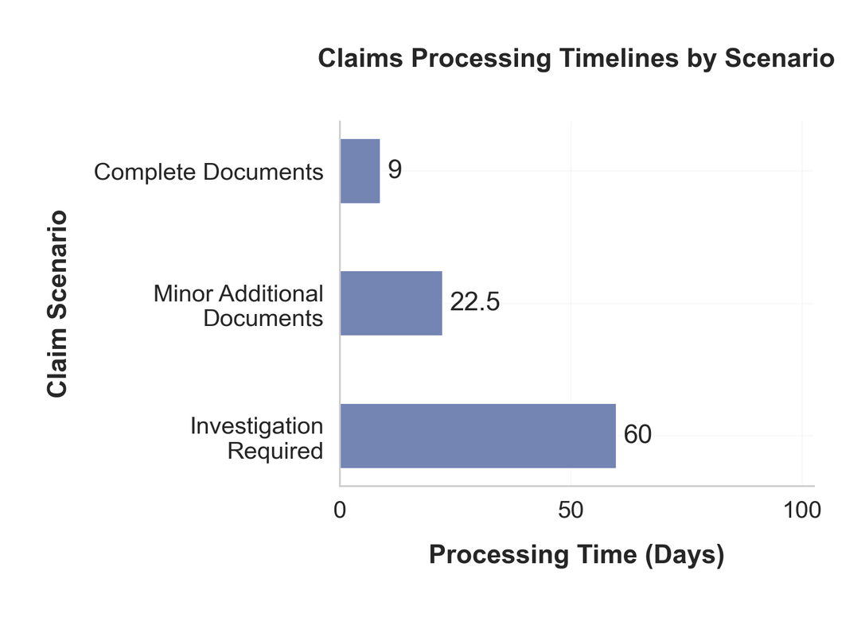

Payment Methods and Options

Tokyo Marine Thailand offers two convenient payment methods for claim proceeds, each with distinct advantages. The recommended method is direct bank transfer to a savings account, which is efficient, incurs no additional fees, and eliminates the risk of check loss in the mail. To receive payment via bank transfer, you must provide a clear copy of the first page of your bank passbook showing your bank account number and account name; note that this method is only applicable for savings accounts.
The second option is check payment via mail, where the check is mailed directly to the policyholder or beneficiary at the address on file [1]. While this method provides a physical payment instrument, it involves longer processing time due to postal delivery and carries a risk of loss or delay in transit. Most customers choose bank transfer for faster, more secure payment receipt. Regardless of payment method selected, ensure your contact information and mailing address are current in Tokyo Marine's records to avoid payment delivery issues.

Customer Support and Contact Information
Tokyo Marine Thailand provides multiple support channels to assist you throughout the claims process. Our Customer Care Team is available Monday to Friday, 8:45 AM to 5:45 PM to answer your questions and provide guidance.

Support Channels
You can reach us through the following channels:
• Customer Service Hotline at 1159 for immediate assistance with claims inquiries and status updates
• Individual Claims Department by phone for specialized claims support and case-specific questions
• Email and online contact forms through the Tokyo Marine Thailand website for non-urgent inquiries
• In-person visits to the Head Office at 1 Empire Tower, 26th Floor, South Sathorn Road, Yannawa, Sathorn, Bangkok 10120, or any branch office nationwide
• Through your servicing agent who can provide personalized assistance and help facilitate your claim submission [1]
For urgent matters outside business hours, you may leave a message and our team will respond on the next business day. Additionally, the TMLTH Touch Point mobile application provides policy information, claim history, and the ability to submit certain claims electronically (E-Claim) directly from your smartphone [3].

Channel Utilization
Customer support channel utilization shows that the phone hotline (35%) and in-person office visits (30%) remain the most popular methods for claim inquiries, followed by agent assistance (25%) and digital channels (10%).
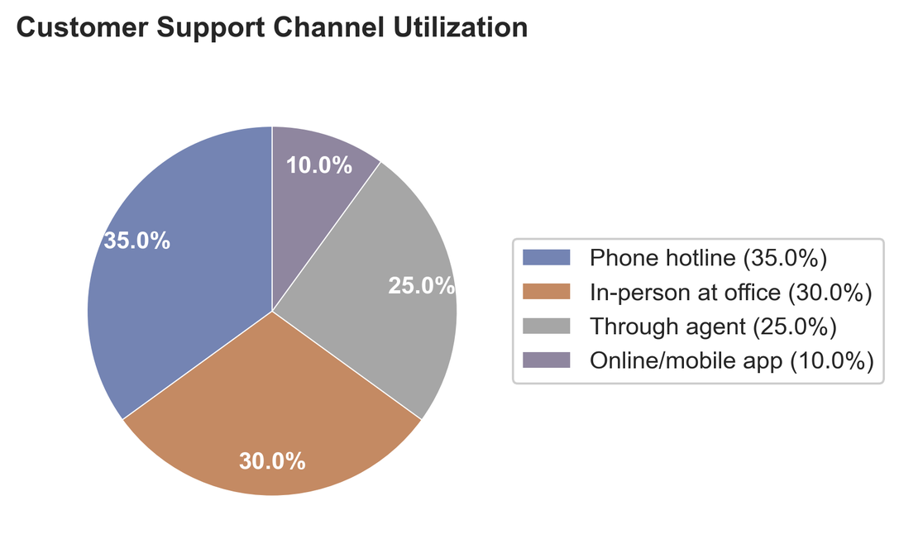

Common Questions and Troubleshooting
Many customers have similar questions when navigating the claims process. Here are answers to the most frequently asked questions.

How can I check my claim status?
You can check your claim status by contacting the Individual Claims Department directly, calling the customer service hotline at 1159, or inquiring through your servicing agent with your claim reference number.

What should I do if my documents are incomplete?
If you submit incomplete documentation, Tokyo Marine will contact you to request the missing items; respond promptly to avoid delays in processing.

Can I submit documents by fax?
Yes, you may fax claim documents to 02 619 4083, though original or certified copies may still be required for certain documents such as death certificates [1].

What happens if my claim is denied?
If your claim is denied, you will receive written notification explaining the reasons; you have the right to appeal the decision by providing additional documentation or clarification addressing the denial reasons.

How long is the cooling-off period?
Thailand insurance regulations provide a 15-day cooling-off period for retail insurance policies during which you may cancel and receive a refund [2].

What if the beneficiary information is incorrect?
If beneficiary information on your policy is incorrect or outdated, contact Tokyo Marine immediately to update the beneficiary designation form; the proceeds will be paid according to the most recent designation on file regardless of other documents.

Tips for Smooth Claims Processing
Following these practical tips can significantly improve your claims experience and reduce processing time.
• Keep your policy documents organized and stored in a safe, accessible location that family members can find when needed.
• Inform at least one trusted family member or beneficiary about your policy details, including the policy number, insurer name, and location of documents.
• Review your policy annually to ensure beneficiary designations are current, especially after major life events such as marriage, divorce, or birth of children.
• Maintain up-to-date contact information with Tokyo Marine, including current address, phone number, and email.
• Take time-stamped photos and keep detailed records immediately after any incident that may lead to a claim.
• Submit all required documents together in one complete package rather than piecemeal submissions to avoid processing delays.
• Choose direct bank transfer as your payment method and provide accurate bank account information.
• Respond promptly to any requests from the claims department for additional information or clarification.
• Keep copies of all documents you submit for your personal records.
• Consider working with your servicing agent who can guide you through the process and help ensure completeness.
• Read your policy document carefully before you need to file a claim so you understand coverage, exclusions, and requirements.
• For medical claims, always obtain pre-authorization from Tokyo Marine before planned procedures when required by your policy terms.

References
[1] Claims process | Tokio Marine life
[2] Insurance Claims & Disputes in Thailand: How to Get Paid
[3] TMLTH Touch Point - Apps on Google Play

